**Lab 5 – SQL**

**Due Start of Class February 25, 2016**

**Each problem is worth one point. No partial credit will be given. This lab is worth a total of 15 points.**

**Use hostname: classdb.jccc.edu**

**From this lab forward, please notice if a result table is in a particular order. If it is you must use the order by clause. Failure to do so will result in 0 points for that specific problem.**

**Place all answers into ONE .sql file. Attach that file to the Dropbox for Lab 5 in D2L. Only one .sql file will be accepted.**

**\*\*\*\* Use the Dual table for the following questions \*\*\*\***

**1. Display the integer division, full division, and mod of 7/3. Use the Dual table.**



**2. Display the ceiling and floor values of 5.768 and -2.35. Use the Dual table.**



**3. Display the absolute value of -3.4, 0 and 4.01. Use the Dual table.**



**4. Using the value 9.58348, display the following result table using only the round function.**

**Use the Dual table.**



**5. Display the number of years between August 15, 2011 and December 4, 1865.**

**Use the Dual table.**



**6. Display the current date and time one hour ago. Use the Dual table. Your answer will be**

**dependent on todays’ date and time.**



**7. Display the current year. Use the Dual table.**



**8. Display the results of solving the quadratic formula using the following values: a=1, b=5,**

**c=1. Use the Dual table.**



**9. Display the current date 3 months ago. Use the Dual table. Your answer depends on**

**when you run this query.**



**10. Display the last day of the current month. Use the Dual table. Your answer depends on**

**when you run this query.**



**11. Display the time zone used by the Oracle database server. Use the Dual table.**



**12. Display the number of days left in the current month. Use the Dual table. Your answer**

**depends on when you run this query.**



**13. Using the power function, display the number 7 raised to the 8th power. Use the Dual**

**table.**



**\*\*\*\* Use the Student table space for the following questions \*\*\*\***

**14. Display all students that enrolled in January. Use the Enrollment table.**

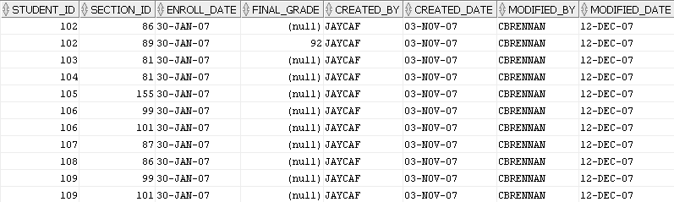

**15. Display all course costs as per the following result table. You must use the Case function.**

**Use the Course table.**

**Partial Result Table (30 rows total)**

